Name and Student ID: Wyatt Duberstein 629635057 Lab Section: 19

Date: 9/14/2020

**PRELAB:**

**Q1.** Read section 3.0 and fill in the truth table below for Design 1 (*the farmer’s problem*). Then use it to construct the POS expression.

|  |  |  |  |
| --- | --- | --- | --- |
| **Cabbage** | **Goat** | **Wolf** | **Alarm** |
| 0 | 0 | 0 | 1 |
| 0 | 0 | 1 | 1 |
| 0 | 1 | 0 | 0 |
| 0 | 1 | 1 | 1 |
| 1 | 0 | 0 | 1 |
| 1 | 0 | 1 | 0 |
| 1 | 1 | 0 | 1 |
| 1 | 1 | 1 | 1 |

POS Logic Expression: CG’W + C’GW’

**Q2.** Read section 4.0 and fill in the truth table below for Design 2 (*adding the farmer*). Then use it to construct the SOP expressions.

|  |  |  |  |  |
| --- | --- | --- | --- | --- |
| **Farmer** | **Cabbage** | **Goat** | **Wolf** | **Alarm** |
| 0 | 0 | 0 | 0 | 0 |
| 0 | 0 | 0 | 1 | 0 |
| 0 | 0 | 1 | 0 | 0 |
| 0 | 0 | 1 | 1 | 1 |
| 0 | 1 | 0 | 0 | 0 |
| 0 | 1 | 0 | 1 | 0 |
| 0 | 1 | 1 | 0 | 1 |
| 0 | 1 | 1 | 1 | 1 |
| 1 | 0 | 0 | 0 | 1 |
| 1 | 0 | 0 | 1 | 1 |
| 1 | 0 | 1 | 0 | 0 |
| 1 | 0 | 1 | 1 | 0 |
| 1 | 1 | 0 | 0 | 1 |
| 1 | 1 | 0 | 1 | 0 |
| 1 | 1 | 1 | 0 | 0 |
| 1 | 1 | 1 | 1 | 0 |

Canonical SOP Logic Expression:

Simplified SOP Logic Expression: F'GW + F'CG + FC'G' + FG'W'

**LAB:**

**3.0** Hardware results demonstrate correct code. TA Initials: **PS**

Schematic screenshot:

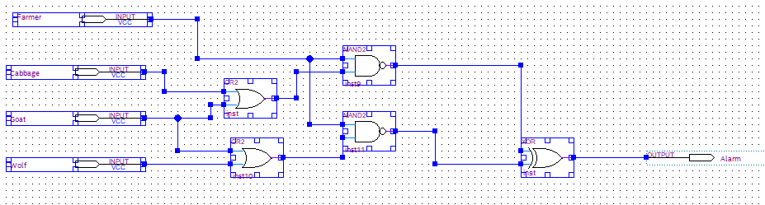

Structural Screenshots:

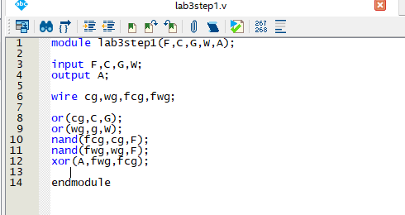

Behavioral Screenshots:

**4.0** Hardware results demonstrate correct code.

Screenshot:

Step 1:

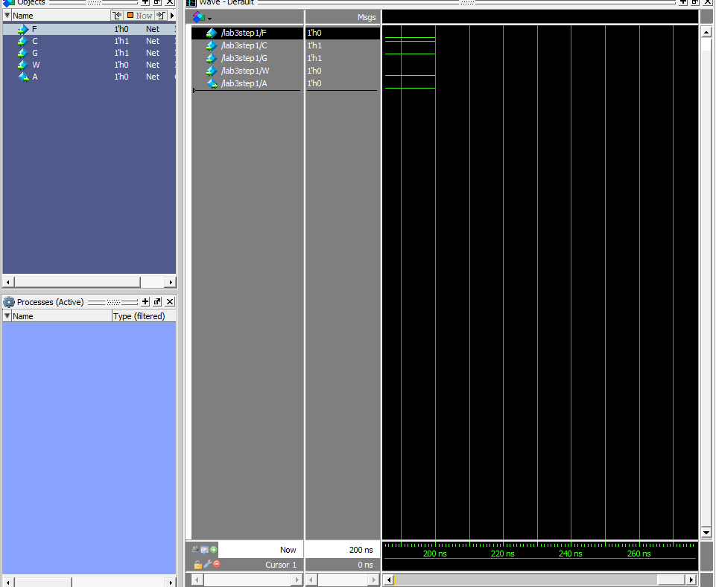

Step 2:

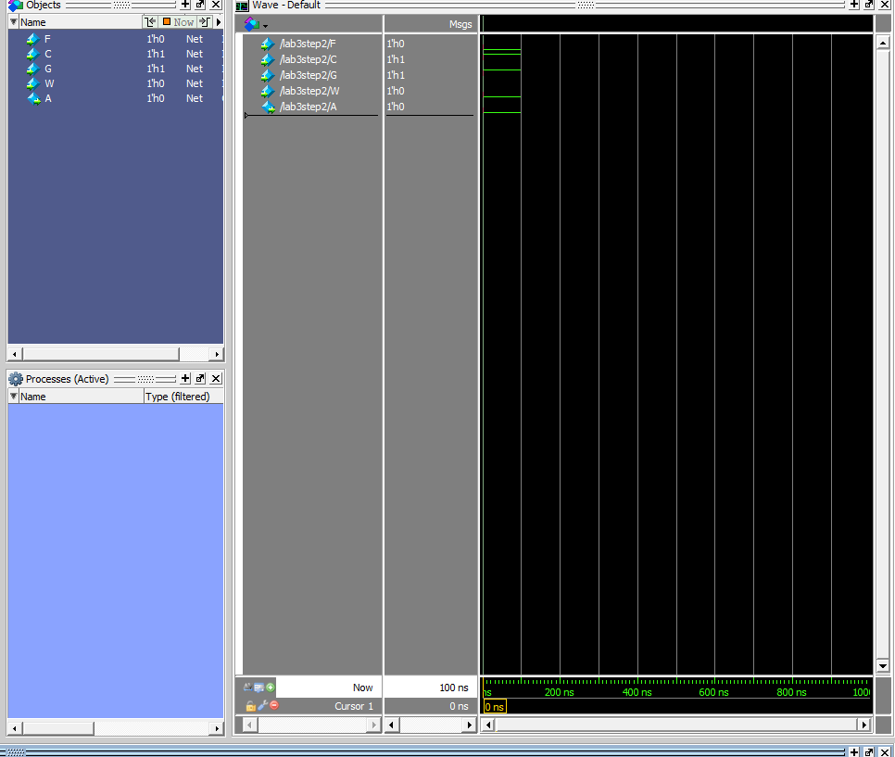

Step 3:

